

# **Behaviour Policy**

**Autumn 2024**

|  |  |
| --- | --- |
| **Review Date** | October 2024 |
| **Approved** | Ful Governors |
| **Ratified** | (pending) |
| **To be Reviewed** | October 2025 |
| **Policy Lead** | Ms I Galmes |

**Behaviour Policy**

**Autumn 2024**

**Rationale:**

We expect high standards of behaviour and conduct in all aspects of school life and seek to maintain these standards by positive reinforcement supported by sanctions as necessary. We believe that it is the right of all students to be educated in an environment free from disruption by others.

This policy sets out the framework for the behaviour and conduct within the school, based on the principles of Assertive Discipline and Trauma Informed Schools.

**The focus of Assertive Discipline** is on teaching students responsible behaviour. It is a proactive and preventative approach and goes beyond establishing basic discipline in the classrooms **to creating learning environments in which students learn to choose appropriate, responsible behaviour for themselves.**

**The focus of Trauma Informed Schools** is to ensure that staff make themselves “emotionally available” to our students therefore building positive relationships.

**Aims:**

* to follow the principles and guidelines of Assertive Discipline
* for the application of sanctions to be **“Firm. Fair. Consistent**
* to create an orderly environment both inside and outside the classroom which enables ‘teachers to teach and students to learn’
* to reward students for good behaviour

**Guidelines:**

# Positive Behaviour Management at Fir Vale School

We expect all staff in school to follow these guidelines:

* to support the school’s basic expectations, The Choice and Consequence System and The Recognition System, and to establish and clearly define limits of acceptable behaviour.
* to teach students to consistently follow the systems to promote positive behaviour and to help them to choose to behave responsibly at all times.
* to provide students with **consistent positive encouragement and recognition** when they make positive choices.
* to adopt a positive, assertive manner when responding to students;
* Students trust and respect the calm, consistent and caring presence of an assertive teacher.
* to follow communication systems by completing consequences, communicating with parents and liaising with relevant staff.

## Communication and Recording

Good communication is essential in dealing effectively with behaviour problems. The system for the recording of incidents and for communicating with parents/guardians is an integral part of the process.

**Recognition referrals:**

These should be issued by staff in line with the whole school recognition system. An update on

the ClassCharts app is there for parents to inform them of any recognition points issued.

**Electronic Consequences:**

Staff should complete these when a student reaches C2/C3 by using ClassCharts. This will

then alert parents through the app. Year Team typically respond to C2s and the Behaviour

Team typically responds to C3s. If a student receives C3 Repeat/Serious Behaviour, staff are to

request a support visit using ClassCharts. The Behaviour Support teacher will support the

student to modify their behaviour and return to learning.

If a student chooses to continue to behave in a way that does not meet Fir Vale

expectations, they may be removed from the classroom and placed in isolation to allow Year

Teams to decide on an appropriate sanction with support from SLT where required.

**Responsibility for Action?**

* All staff and students have a responsibility for behaviour, in and out of the classroom.
* Each faculty is responsible for issues arising from lessons. The modelling of positive behaviour management and Trauma Informed Schools principles will support this process. Faculty Leaders should monitor electronic referrals and provide appropriate intervention
* Faculty Leaders to highlight any emerging patterns and to be proactive in addressing issues in the first instance with individual staff members by offering support, coaching, strategies where necessary
* Faculty meetings should to be used to look at subject-wide picture surrounding behaviour management and progress of assertive discipline fostering the ideal teaching and learning environment

# **Behaviour Support Routines and Expectations**

# Role of the Behaviour Support person in the process

Behaviour Support is only sent for following the member of staff having tried to use a range of strategies to encourage the student to comply, or there is an instance of dangerous behaviour (for example violence).

**Follow-up:**

* All sanctions for behaviour resulting in the need to request Behaviour Support are decided on by the Pastoral Team and Senior Leaders.

**Summoning Behaviour Support:**

* To summon Behaviour Support, the member of staff must use “C3 Repeat/Serious Behaviour” on the ClassCharts system which will immediately alert the Behaviour Support person directly, who will endeavour to respond as soon as possible

### Progression and Suspensions

# Progression

The system of recording through ClassCharts automatically informs the Year Team, Form Tutor and Behaviour Support so that information from consequences may be shared with key members of staff for appropriate intervention.

**Routines for Learning**

* Greet students at the classroom door by name and usher others off the corridor and into the correct classrooms.
* Reminder of expectations at the start of the lesson; uniform on, coats off, bags on the floor; planners on the desk; equipment out – in accordance with the expectations. Use of praise for those ‘doing the right thing’.
* Specified seating plan using ClassCharts.
* Students complete a Do Now task for immediate engagement with learning.
* Electronic register taken on ClassCharts.
* Re-cap given of previous lesson’s learning.
* Learning objectives shared either orally or on the board.
* **Give clear direction** - whenever we need a change in behaviour.
* **Provide supportive feedback** - by positively recognising those who follow instructions.
* **Take corrective action** - to redirect those who are not following instructions, using least intrusive methods first wherever possible (e.g. non-verbal reminders).
* **Use language of choice** and time for reflection as it allows students to reflect on their behaviour and the consequences of following one or another course of action.
* When giving instructions/direction apply the **4Ts**:
  + **Time –** How long do students have for the activity?
  + **Task** – What is the task and why are the students doing it? Explaining the purpose.
  + **Team** – Are students working independently or as a group to complete the task?
  + **Target** – What should the task look like when it’s completed?
* Use of restorative conversations where possible which include comments about the negative impact on progress.
* Choice and Consequence system followed consistently, and records of consequences issued on ClassCharts.
* Consistency in delivering sanctions.
* Lessons follow the ‘Teach, Check, Practise’ format. New content is explicitly introduced and modelled, MWBs or other methods of checking for understanding are used to ensure the class have understood, re-teaching takes place where this is not the case, and students are given time to practise their new learning independently. Scaffolding is provided to support students to ensure all can access learning.
* Effective praise and recognition at all times. Recognition points should be on ClassCharts.
* Following assessments students re-teaching of content identified for improvement, or opportunities for additional practise, take place, helping students close gaps in learning.

**Suspensions**

* Whilst it is the responsibility of an individual school to establish what is acceptable and what is unacceptable behaviour – and to decide the appropriateness of suspension as a sanction, for the latter, all schools/Academies operate within a National Legal Framework and within guidelines issued by the DFE. The Guidance states that there is an expectation that it will be followed unless there is a good reason to depart from it. We possess a well-defined hierarchy of actions designed to support students who behave inappropriately, with the aims of improving behaviour and minimising suspensions. Fir Vale School will work in partnership with the locally agreed protocols, co-operating with the local cluster of schools to maintain the inclusive aspirations of the city.
* Suspensions can only be carried out by the Headteacher or Deputy in her absence. Each suspension must be judged on the specific context of the particular event or sequence of events in consultation with the Assistant Headteacher and external agencies where appropriate.
* It is the policy of Fir Vale School to use suspensions sparingly in response to serious breaches of the School’s Code of Conduct, the detail of which is made explicit to all students and when suspension is used as a sanction it is within the context of the guidelines listed.

Guidelines list the following as unacceptable behaviour warranting suspension from School, stating that in some cases it would be appropriate for the Headteacher to consider permanent exclusion:

* A deliberate assault on a member of staff
* Bringing a weapon into school
* Any assault with a weapon or other implement against staff
* A deliberate assault on another child
* Selling, using and distributing drugs within the school
* Sexual assault and Peer on Peer assault
* Persistent racial abuse
* Persistent abuse/bullying including physical abuse
* Verbal threatening and intimidation of staff
* Verbal abuse to staff
* Bullying committed via social networking media/electronic means
* Cumulative disruptive events when the school has attempted to gain compliance through other sanctions
* Persistent and entrenched refusal to comply with expectations

**Automatic sanctions will apply in the following cases:**

* The school has a zero-tolerance policy on drugs in order to signal to all young people in our learning community that illegal drugs have a pernicious and damaging effect not only on individuals but whole communities. Selling, possession, using or distributing illegal drugs within the school will invoke an immediate permanent suspension.
* Fir Vale School takes health and safety very seriously, and to this end views the setting of the fire alarm to be a threat to a safe environment. Profound disruption to learning occurs during the deliberate setting of the alarm, consequently this will be dealt with by an immediate suspension and parental meeting.

**Government guidelines state that suspension should not be seen as a response to:**

* Students who cannot comply with uniform as dress code (as opposed to wilful defiance)
* Minor disruptive or other offences e.g. not doing homework
* Pregnancy
* Smoking
* Non-attendance.

**The school does not see suspension as appropriate in the following cases**:

* Minor breaches of discipline;
* Poor academic performance;
* Truancy or lateness;
* Non-compliance with uniform regulations.

Most suspensions will be of 1 to 5 days duration, with work available to be done at home. A reintegration meeting is sought in all cases of suspension and when possible this is arranged at the time of suspension to take place on or before the return of the child to school. In all cases the child is interviewed by either the Head of Year, Behaviour Team or a senior member of staff on his/her return from suspension outlining the conditions of the reintegration. All suspensions are notified to the LA. Termly suspension updates will be forwarded as required to the Chair of the Governing Body, with regular reports being made to the relevant Governing Body Sub-Committee

Suspensions will rarely extend beyond 5 days, and where this occurs provision will be made for the student to maintain their education. Lengthy suspensions, or cumulative suspensions amounting to beyond 15 days will always be accompanied by a meeting between parents/carers, and the School Governing Disciplinary Panel. In cases of severe behaviour an emergency convening of the discipline panel will be triggered. Where the student’s record or an incident warrants permanent suspension, the School will contact the LA Inclusion Team to ensure appropriate notification.

Return from suspension meetings are a pre-requisite to re-integration for lengthy suspensions. Return from managed moves etc and will involve the signing of a behaviour contract outlining school expectations

The Governors believe in actively supporting a good climate for learning for all students, balancing that with individual needs and circumstances. Governors support the school in promoting inclusion through participating in re-integration under mutual agreement with parents following suspensions where a child appears to be increasingly vulnerable to permanent suspension.

A decision to exclude a child permanently is a serious one. It will usually be the final step in a process for dealing with disciplinary offences following a wide range of other strategies, which have been tried without success. It is normally used as a last resort, but in exceptional circumstances it may be appropriate to permanently exclude a child for a first or “one off” offence.

These might include:

* Serious actual or threatened violence against another student or a member of staff
* Sexual abuse or assault
* Supplying an illegal drug
* Carrying an offensive weapon

The school will continue to provide education for a student who remains on roll and will set work for the student. In the case of an suspension of more than 15 days, the school will consider how the student’s education will continue, how his/her problems night be addressed in the interim; and reintegration post-suspension.

It may be necessary to make a Risk Assessment for any student who carries out a “one-off offence” to predict the likelihood of repetition and to evaluate the possible health and safety impact upon other students.

Parental co-operation forms part of the contract between the school and all parents of students at the school. A refusal to abide by the terms of a suspension may be considered a breach of contract.

**Appeals**

Parents/carers are entitled to appeal to the governing body against any suspension through a letter stating the intention to appeal to the Clerk to the Governing Body at the School. A hearing will be set up as quickly as possible, but within 10 days at the latest. The governors' decision is final.

Parents have a further right to appeal where the Headteachers decision is upheld by Governors. This independent appeal panel will be set up and held within the statutory guidelines. Parents should inform the Clerk to Governors of their intention to appeal.

**Detentions - Procedures**

* A detention is set by the Pastoral Team, Behaviour Support, teaching staff where some breaches occur, or SLT. They are carried out by the Pastoral Team and supported by teachers on a rota. The Pastoral Team will also coordinate any restorative conversations which may be required.

**Off Site Directives and Extended Off-Site Directives**

**Off Site Directives (OSD)**

**The Process**

An Off-Site Directive is a sanction which can be used to improve behaviour. It involves the student spending a period of time out of Fir Vale School. They attend one of the partner schools and are isolated in their isolation room which is the equivalent to our IEU –Internal Exclusion Unit.

An OSD can be for up to five days. Anything beyond five days is classed as an Extended Offsite Directive.

There is a clear process to follow to ensure the safety of the student and efficient communication with all who are involved with the process.

**Incident occurs**

Pastoral team considers recent behaviour and previous sanctions. OSD is identified as an appropriate sanction. Go to Assistant Head Teacher - Behaviour

Assistant Head Teacher - Behaviour decides whether the OSD takes place. If yes, Assistant Head Teacher - Behaviour seeks permission from Head Teacher and consults with AHT Attendance

Yes – Assiatant Head Teacher approaches receiving school. Once agreed Pastoral Admin does the following:

1 – Completes the OSD paperwork

2- Sends paperwork to receiving school – ccs in Attendance and Admin team

3- Logs on OSD tracker

4- Logs on Class Charts

Pastoral team contacts parents and arranges how student will get there.

If an incident occurs during the morning session and it is decided that the student should complete an OSD that afternoon, the Assistant Head Teacher - Behaviour will always discuss this with the Head Teacher before the process is followed. Parents and the attendance team will be informed.

**Attendance team role**

**Outbound**

Check if our student has arrived at receiving school. If not, make attendance call. If student doesn’t attend, log on OSD tracker.

**Attendance and Admin team role**

**Inbound**

Admin/Reception team signs in the student and alerts behaviour team of arrival.

Attendance team checks inventory and reports student’s arrival to the sending school.

External students sign out at 2:30pm.

If a student doesn’t attend the OSD, they return to school after the number of days they were meant to attend at the receiving school. It is logged on the OSD tracker and Class Chart notes.

**Extended Off Site Directives (EOSD)**

**The process**

An Extended Off-Site Directive is an opportunity for a student to have a fresh start at a different school. It is on a trial basis.

Students on an Extended Off Site Directive are reviewed every month at the behaviour panel which is led by the Local Authority. The Assistant Head Teacher - Behaviour attends these panels

Where a decision is made to offer an Extended Off Site Directive the following process is followed:

1. Pastoral team approaches Assistant Head Teacher - Behaviour
2. Yes – Assistant Head Teacher - Behaviour discusses with head teacher
3. Yes – Assistant Head Teacher - Behaviour speaks to parents /carers and student to select 2/3 schools to approach
4. Assistant Head Teacher - Behaviour approaches schools
5. School agrees – basic paperwork sent by Pastoral Admin and ccs Attendance and Admin team

EOSD Paperwork

* Timetable
* Attendance
* Recent progress report

6 – Where there are safeguarding concerns and /or SEND. The safeguarding team/SEND team will contact their counterparts at the receiving school.

7 – Student is invited for an induction meeting.

8 – This is reviewed every four weeks.

Where we welcome a student from a partner school, the same process is followed.

If it is an urgent move from one school to another, 5 days for staff to prepare should be in place. If a student does need to move more urgently, the IEU should be used until the preparation process has been completed.

OSD / EOSD Students are “D” coded. Host schools must put students on roll, even if only for one day. This will happen when they arrive in the building.

Interventions

**Wave 1**

|  |
| --- |
| Early leave pass |
| Time out pass |
| Toilet Pass |
| Medical pass |
| Link pass – general |
| Link pass – social |
| LZ pass |
| Classroom strategies updated |
| Tutor targets / year teams |
| SEN Flag plan updated |
| Tutor Check in |
| PPS |
| Restorative conversations |
| Parent Meeting |
| Year team drop in timetable |

**Wave 2**

|  |  |
| --- | --- |
| HoY or DHoY 1-1 mentoring | Behaviour |
| HoY or DHoY small group mentoring | Behaviour |
| Behaviour team values intervention | Behaviour |
| Academic Lead values Intervention | Behaviour |
| DDA values Intervention | Behaviour |
| LSA in class | SEND |
| MTT SEN Bespoke | SEND |
| SEND Testing | SEND |
| Lexonic – Leap | SEND |
| Lexonic – Advance | SEND |
| Talk about - SEND | SEND |
| Anxiety gremlin | SEND |
| Angry gremlin | SEND |
| Precision teaching | SEND |
| Social communication groups | SEND |
| Nurture group | SEND |
| Lego therapy | SEND |
| Friendship groups | SEND |
| Parent meeting Year Team | Behaviour |
| Parent meeting academic lead | Behaviour |
| Behaviour AH parent meet | Behaviour |
| KS4 mentoring – MAL | Behaviour/SEND |
| Raising aspiration - careers | Behaviour |
| Football Targets | Behaviour |
| Flag plan behaviour | Behaviour |
| EAA – named | Behaviour |
| OSD | Behaviour |
| Reasonable adjustment to social times | Behaviour |
| Home visit | Behaviour |
| Parents evening - targeted | Behaviour |
| Healthy lifestyles - EST | Behaviour |
| SLT Targets | Behaviour |
| SLT behaviour review meeting | Behaviour |
| Specific subject intervention | Behaviour |

**Wave 3**

|  |  |
| --- | --- |
| MTT Behaviour | Behaviour |
| Dave Campbell | Behaviour |
| Extended OSD | Behaviour |
| CYT – 1:1 and group | Behaviour |
| Team around the school | Behaviour |
| Sheffield ASD referral | SEND |
| Ed Psych | SEND |
| SALT | SEND |
| CAMHS | SEND |
| Other outside agencies? ADD MGI | SEND |
| Safe Task force | Behaviour |
| Unravel Counselling | Behaviour/SEND |
| AP | Behaviour/SEND |
| SYEDA – eating disorders | SEND |
| Pre Gov panel | Behaviour |
| Think for the future mentoring | Behaviour/SEND |
| Secondary Inclusion Panel | Behaviour/SEND |

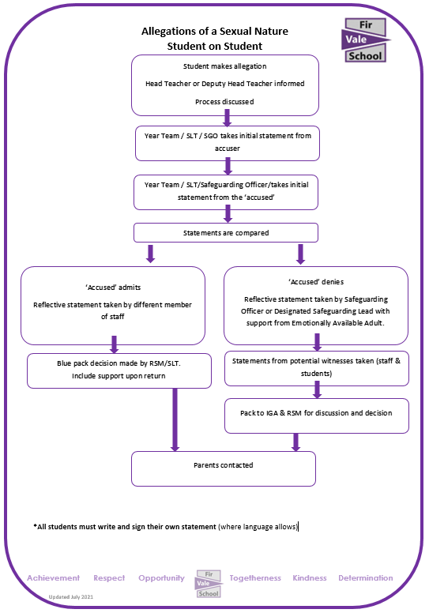

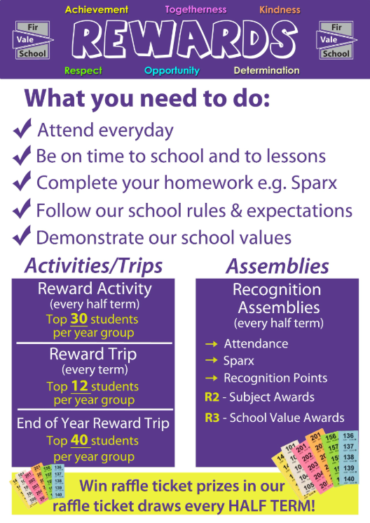

**Recognition and Consequence**

