# Our Ref: RSM/GOX/RemindertoParents

30 January 2023

Dear Parent / Carer

I write to remind you about three things:

**Wednesday 1st February - Y11 focus day**

As some of our teachers are striking, we will only be open to Y11. Years 7-10 will not be at school. You can find work for them on:

<https://www.firvale.com/our-school/home-learning/home-learning-packs/>

**Uniform**

We recently wrote to you to remind you about uniform standards. Please come into school if you need to buy new items of uniform. Alternatively, you can buy plain black PE tracksuit bottoms from stores such as Asda and Primark. No logos (apart from Fir Vale logos) are allowed. Please come and see us if you need help with uniform.

**Vapes**

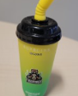It has come to our attention that there are several shops locally selling vapes to school children. This is illegal. It is against the law to sell vape products to anyone under the age of 18. We have already reported these to the police. There is a worrying trend for these to be directly marketed at children, using bright colours and being designed to look like sweets or drinks (see picture). There is no guarantee what is in these vapes. Any child caught with a vape (regardless of whether they have smoked it) will have a suspension from school. Please reinforce this message with your child and ensure they understand the seriousness of the issue.

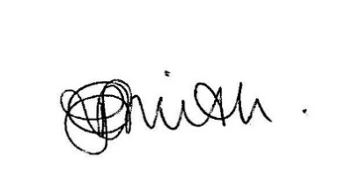Yours faithfully

Rachel Smith

Headteacher

If you need a translator to understand this please call the school on 01142439391

"إذا كنت بحاجة إلى مترجم لفهم ذلك ، يرجى الاتصال بالمدرسة 01142439391.

Te tumenge kampola interpretos hoj te rozuminen feder ta vicinen pre kada cislos 01142439391