Our Ref: IGA/lateness/March2024

19 March 2024

Parent / Carer of

Dear Parent / Carer
Lateness to school and lessons
Part of being responsible and well organised is the ability to arrive on time. Timekeeping is a vital skill and it is something we try to teach our students every day. To support our students in becoming even better at timekeeping, we are introducing the following changes on the week beginning 25th March 2024.
Y10 students will arrive to school and leave through the main front gate.
To be on time your child needs to arrive through their Year Group gate at 8:40am. At 8.44am, the side (for Y9 & Y11) will be locked. Students are expected to be sitting in their Tutor rooms by 8.45am. If they miss coming through their own gate they will have to come through the front gate and into the dining room where the year teams will support them by checking uniform and bags. At this point, they will be set a same day late detention of 60 minutes.
Learning time is precious. We expect our students to be in class on time. It does not take any longer than 5 minutes to get from one class to another. If students arrive 6 minutes or more late to lessons, they will be set a 60 minute detention. If they have a valid note from a teacher, the detention will not be set.
Students who are repeatedly late may be placed in isolation or lose their break and lunchtimes. We may ask parents to attend a meeting if this does not improve.
How can you help?
If you know your child is going to be late for a valid reason, contact the school.
Help your child get ready the night before school so that they leave the house on time. Make sure that full uniform, bag and equipment are ready.
Set an alarm to get your child out of bed, giving them time to prepare for the school day.
Speak to your child about the importance of arriving on time. This will be a valuable tool from now and into adulthood.
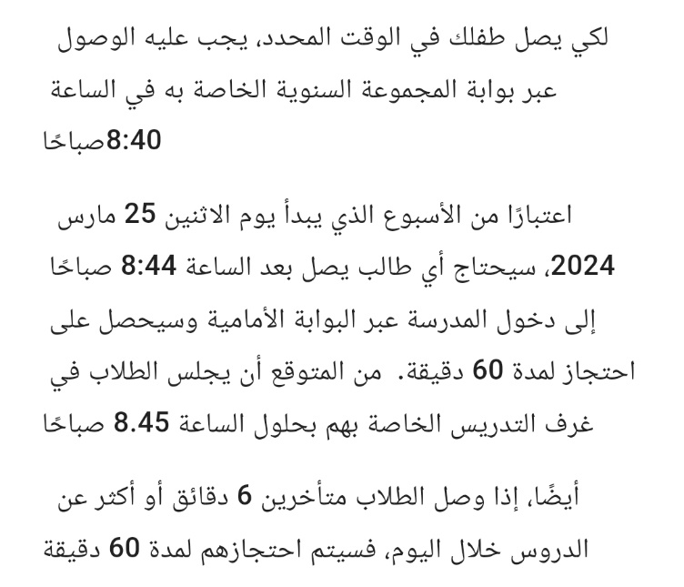
As always, we are very grateful for your support. If you do have any questions, please contact the school.
Aby bolo vaše dieťa načas, musí prísť cez bránu Ročníkovej skupiny o 8:40.
Od týždňa pondelka 25. marca 2024 bude musieť každý študent, ktorý príde po 8:44, vstúpiť do školy prednou bránou a bude zadržaný na 60 minút. Očakáva sa, že študenti budú sedieť vo svojich učiteľských miestnostiach do 8:45
Ak študenti prídu na vyučovanie počas dňa so 6 a viac minútovým oneskorením, bude im stanovené 60 minútové zadržanie.
Yours sincerely,
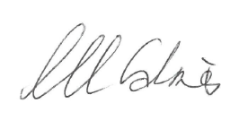
Ms Galmes (Staff)
Assistant Head Teacher

If you need a translator to understand this please call the school on 01142439391
"إذا كنت بحاجة إلى مترجم لفهم ذلك ، يرجى الاتصال بالمدرسة 01142439391.
Te tumenge kampola interpretos hoj te rozuminen feder ta vicinen pre kada cislos 01142439391

