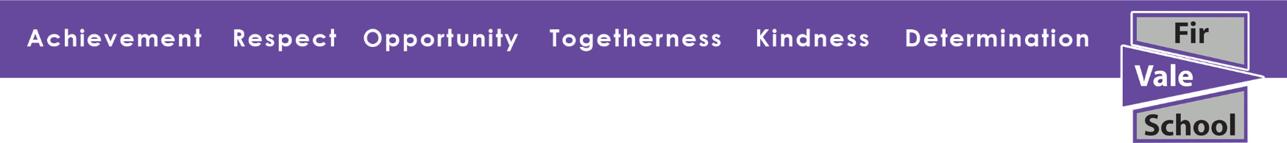

Y7, Y8, Y9 & Y11 Home Learning Day
Tuesday 28th February
Your learning today is going to be chosen by you. You can choose as many topics as you like from:
- Hegarty Maths (online)
- Oak Academy (online)
- Other activities (Fir Vale School website)
Y11 – This is a great opportunity for you to create revision resources and organise your workspace at home.

- Hegarty Maths | - Oak Academy | 3.Other activities
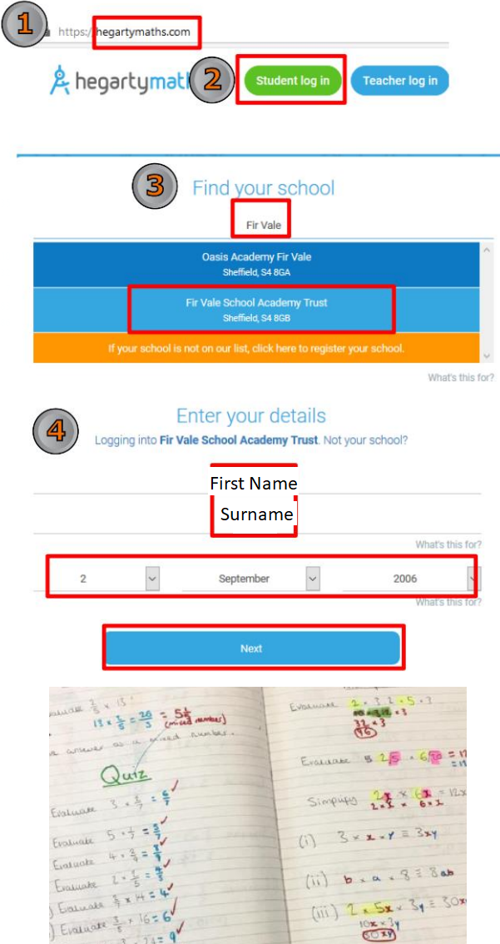 | Log on to:  www.thenational.academy  Click on Classroom:  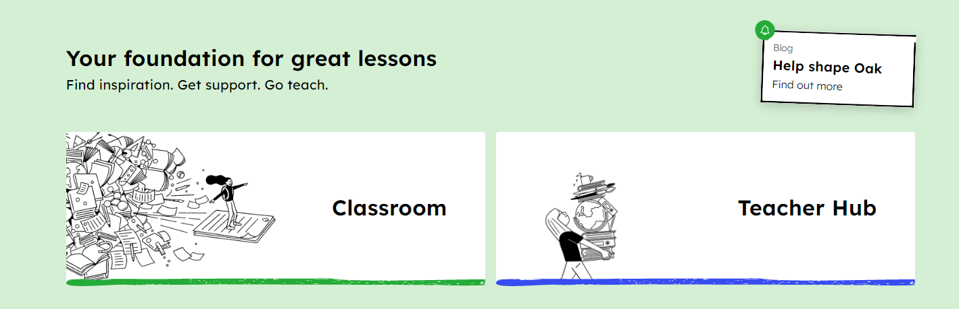  Click on Subjects:  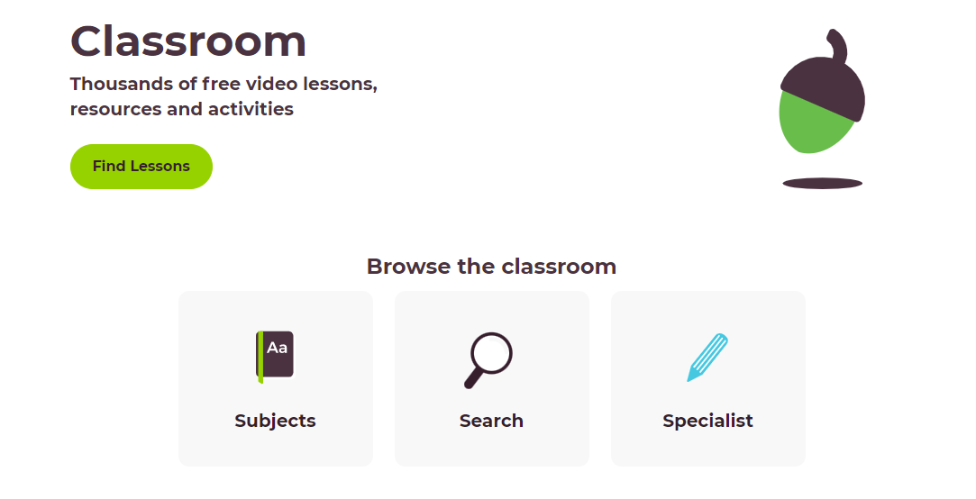  Choose a subject and a topic you would like to work on. Watch the video and do the activities.  You could try 3 different subjects! | - Read a book  Saved on website:  - Photographic Scavenger Hunt  - Sports Challenge  - Journey to School

