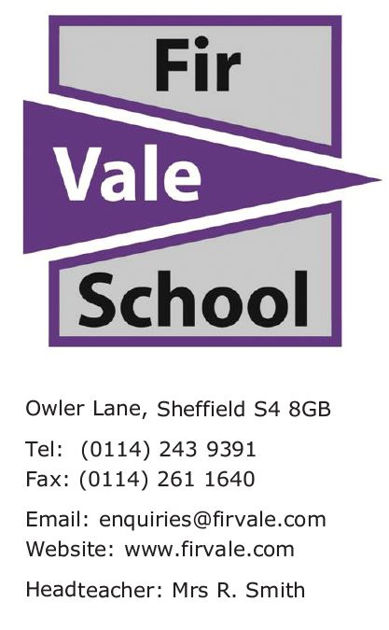
Our Ref: JST/GOX/Welcome to KS4 Information Event

11 September 2023

Parent / Carer of

Dear Parent / Carer
I am writing to introduce myself and to invite you to an event in school on Thursday 21st September 2023. My name is Mr. Storey and this year I will be your child’s KS4 Academic Lead.
As a Y10 student your child has now started the qualifications that they will leave school with at the end of Y11. My role this year is to work with the year group to ensure they make as much progress as possible and leave with the best possible set of results.
As we begin this journey together, I would like to invite you to attend one of the Welcome to KS4 Information Events. This will be held in the Main Hall in school at 3:30pm or 5:00pm on Thursday 21st September 2023. The event will last around 45 minutes and involve:
- Meeting key staff
- Learning what qualifications your child will be sitting
- Finding out about key dates in Y10 (including mock exams and when revision materials will be available)
- Information about how we will support pupils as a school
- Information about how you can support your child’s learning as a parent/carer
I hope that you can attend this event and I very much look forward to working with you closely over the coming year.
Kind regards,

J Storey

Mr. J Storey
KS4 Academic Lead working with Y10

Prosinaf tumen te aven po meetingos stvrtok 21 septembra 3:30 alebo 5:00

If you need a translator to understand this please call the school on 01142439391
"إذا كنت بحاجة إلى مترجم لفهم ذلك ، يرجى الاتصال بالمدرسة 01142439391.
Te tumenge kampola interpretos hoj te rozuminen feder ta vicinen pre kada cislos 01142439391

