Booklet
Day
Y7

Friday 9th December 9am – 3pm
Name:
Year: 7
Tutor:
Tutor:
What do I need to do?
While you are working from home today you will follow your timetable as closely as possible.
- Your timetable for the day is below.
- Work through the activities in this booklet.
- You will need access to the internet for some activities. If you do not have this move on to the next task.
- If you finish and activity early you can do the extension tasks at the back of the booklet
Lesson 1:  9:00am – 10:30am | Science
Break: 10:30am – 11:00am
Lesson 2:  11:00am – 12:30pm | English
Lunch: 12.30pm – 1:00pm
Lesson 3:  1:00pm – 2:00pm | Music
Lesson 4:  2:00pm – 3:pm | Reading
End of home learning: 3:00pm
Have a go at the Extension Activities if you finish early or would like to do some extra learning.

- Ethics – Careers Activity
- Maths
- PE

Science

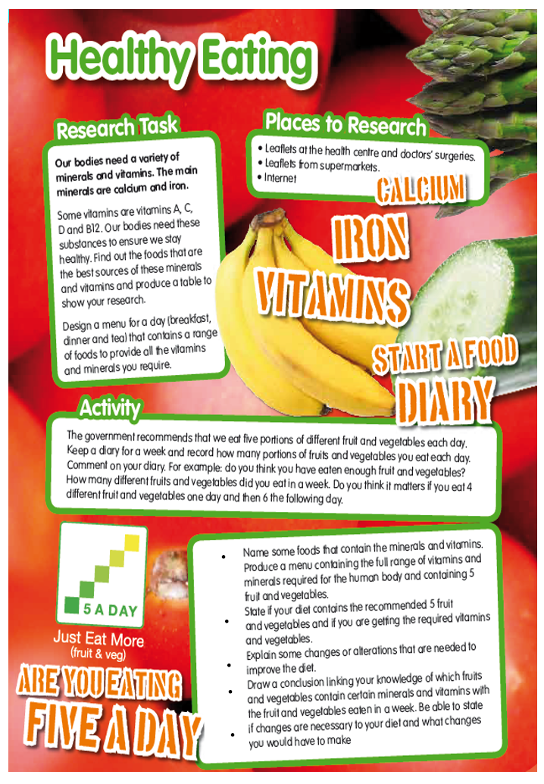
English - Poetry
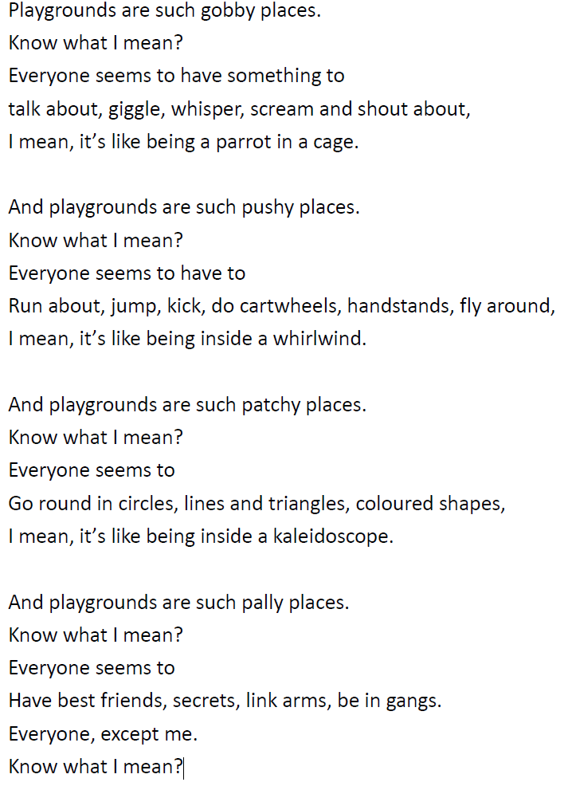
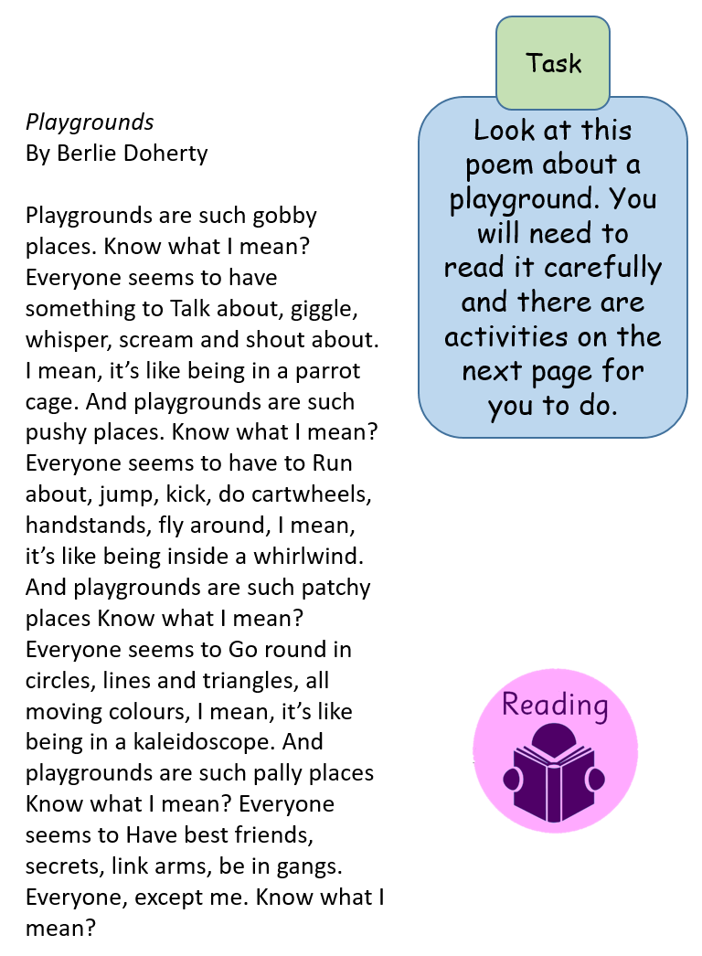

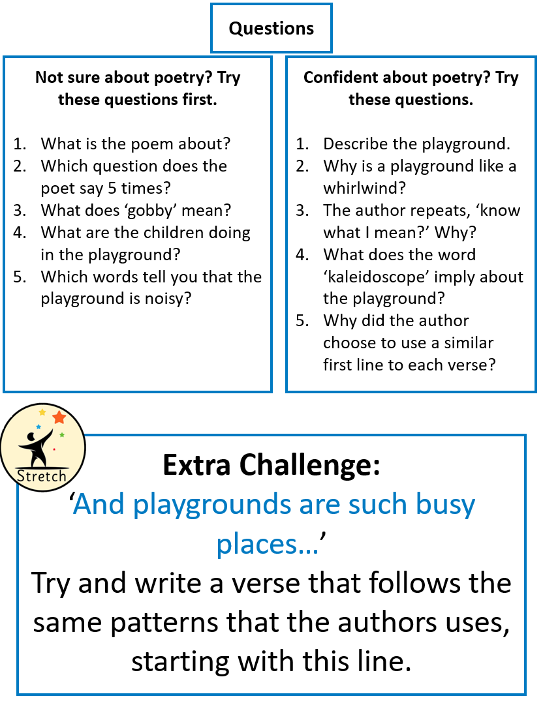

Music

Activity 1
Choose one of these film composers and create a fact sheet about them.
John Williams | Danny Elfman | Hans Zimmer

Use the questions to help you find the information and include pictures of them and the films they have written for.
- What films have they composed music for? (find 5)
- What directors have they worked with?
- What instruments do they play?
- Have they won any awards?
- What is their favourite soundtrack?

Activity 2
Watch part of a film of your choice.
- Write down the name of the film and who composed the music for it.
- Describe the music as you watch the scene – think about instruments, tempo, dynamics and tonality. How do the musical features work with the action?
Which of these features are used in the scene? Diegetic music, leitmotif, a theme, underscore
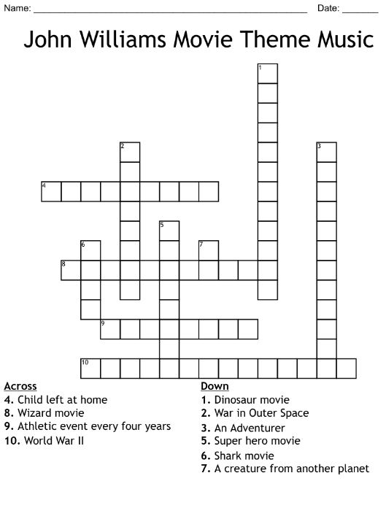
Activity 3
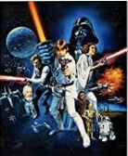
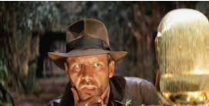
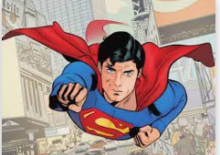
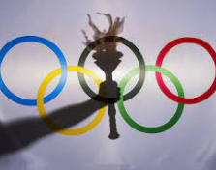

Reading

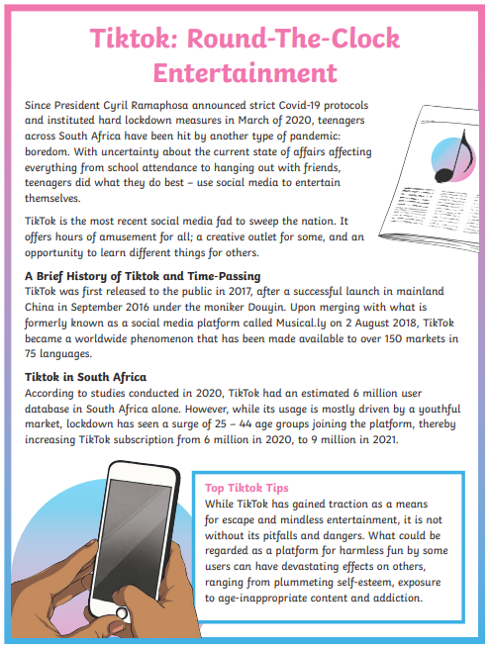

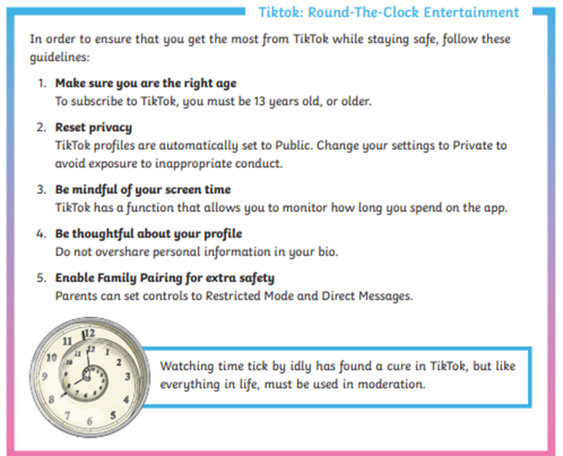

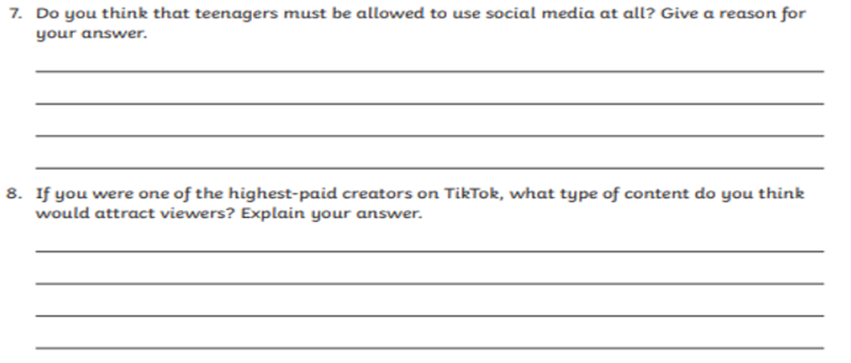
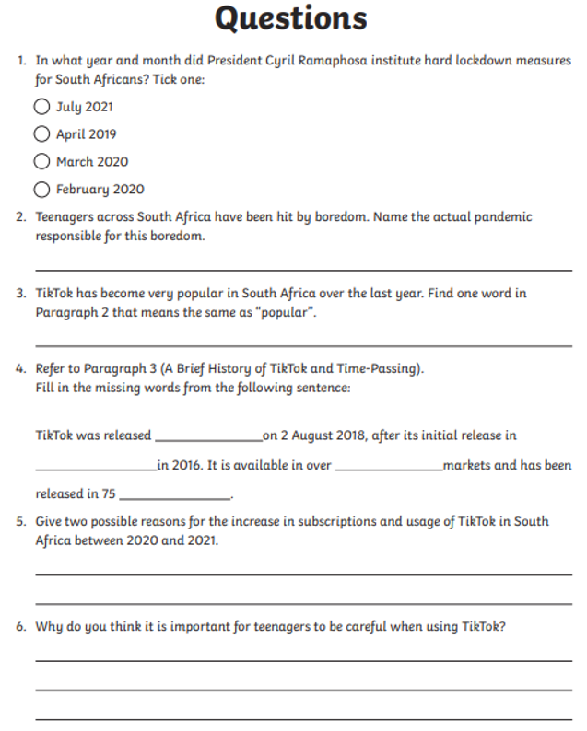
Extension Activity 1 - Careers

Complete each task on paper. You will need access to a phone/computer.

Task 1
Buzz Quiz – Find out what jobs might suit you
https://icould.com/buzz-quiz/?gclid=EAIaIQobChMIkvqg7-q7-AIVjevtCh19yQAsEAAYASABEgLfBPD_BwE

Task 2
- Go to https://nationalcareers.service.gov.uk/explore-careers
- Pick a job category that interests you.
- Now research three different jobs from that area and make notes below.
Example
Title: Assistance Dog Trainer
How to become it:
- a college course
- an apprenticeship
- working towards this role
- applying directly
What you will do:
- work with volunteers who foster puppies and young dogs
- assess dogs to go forward for training
- train dogs to the standards required
- match dogs to new owners
- train dogs and owners together
- provide aftercare and support for owners and their dogs
- keep accurate records

Job 1
Title: _________________________________
How to become it ______________________________________________________________________________________________________________________________________
What you will do
_________________________________________________________________________________________________________________________________________________________________________________________________________
Job 2
Title: _________________________________
How to become it ______________________________________________________________________________________________________________________________________
What you will do
_________________________________________________________________________________________________________________________________________________________________________________________________________
Job 3
Title: _________________________________
How to become it ______________________________________________________________________________________________________________________________________
What you will do
_________________________________________________________________________________________________________________________________________________________________________________________________________

Task 3

Decide which of these three jobs interests you the most.
Go to https://www.sheffieldprogress.co.uk/courses/full_time-course-search
Use Sheffield Progress to research what courses are available in Sheffield, where they are and the grades you need for this career.
Job Title:
Courses
______________________________________________________________________________________________________________________________________
Location
______________________________________________________________________________________________________________________________________
Entry requirements (grades) ______________________________________________________________________________________________________________________________________

Task 4

Complete the skills assessment
https://nationalcareers.service.gov.uk/skills-assessment

I Could – Explore different careers
https://icould.com/explore

https://www.prospects.ac.uk/jobs-and-work-experience/work-experience-and-internships
Research work experience

Extension Activity 2 - PE

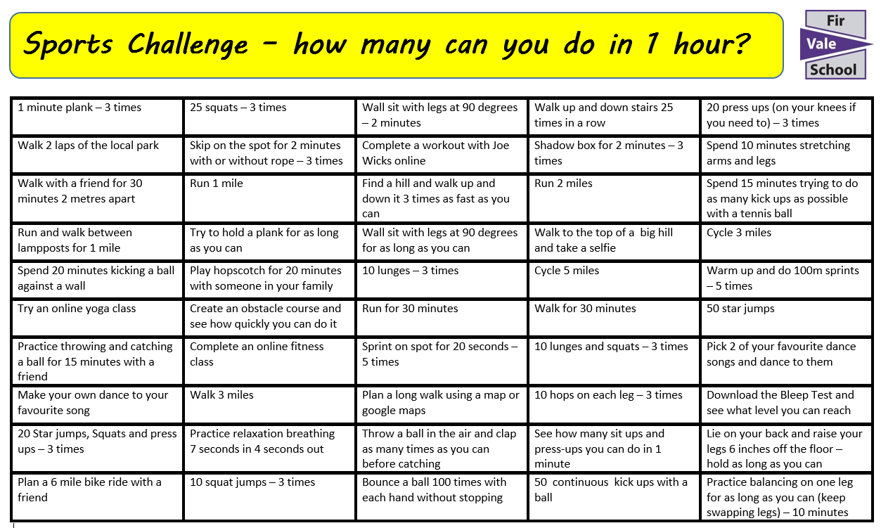

Extension Activity 3 - Maths









