

**Post of Deputy Headteacher**

**L19 – L23**

**£73,509 - £81,010**

**Start date: April 2024 or sooner**

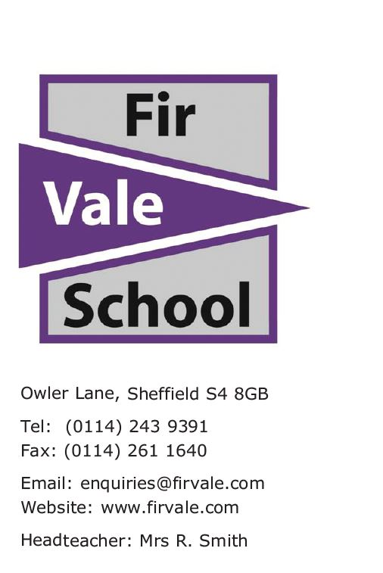Our ref: RSM

8 November 2023

Dear Candidate,

Thank you for enquiring about the post of Deputy Headteacher at Fir Vale.

Our school is an amazing and unique place where staff and students work hard every day towards a common goal.

I am privileged to be Headteacher here and welcome you to come and have a chat and see our school before you apply.

 Our recent Ofsted report recognised that we had improved to ‘good’ in two areas. Although still ‘requires improvement’ overall, we are proud of the improvements we have made as a team in recent years. We are determined to excel in all areas.

 We are looking for an enthusiastic and strategically-minded Deputy to join a team that is relentlessly focussed on ways to improve the lives of our pupils.

 We are currently looking to go into partnership with a strong MAT. It is a good time to join an amazing team.

 If you are interested and want to know more, please contact the school for a chat with me and/or a tour.

Yours faithfully,

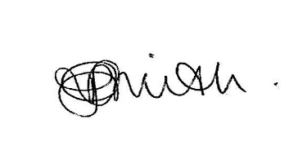

Rachel Smith

**Headteacher**

**The recruitment and selection process**

The recruitment and selection process is set out below.

|  |  |
| --- | --- |
| **Milestone** | **Date** |
| **Post Advertised** | 8 November 2023 |
| **Interested candidates can meet the Headteacher and tour the school** | On request |
| **Closing Date for Applications** | 4pm 23 November 2023 by TES or Apply by email to mshiels@firvale.com |
| **Shortlisting** | Friday 24 November 2023 |
| **Interview process** | Week commencing 4 December 2023 |
| **Successful candidate starts** | April 2024 or sooner |
| **Please complete and return the application form as above either through TES or by email to** [**mshiels@firvale.com**](mailto:mshiels@firvale.com)  You should include a personal statement of no more than 2 sides of A4 explaining:   * **what has prepared you for the role of Deputy Headteacher at Fir Vale School?** * **what are the challenges and opportunities both for our school and for you as one of two Deputy Headteachers?** * **what experience would you bring to help drive higher quality and standards?**   Please look carefully at the person specification, job description and the attached information. Please focus on our context, challenges and how your experiences have prepared you for this role in our school and will mean you will be an effective senior leader. ***Please note we are looking for the right person to join our team. Specific roles and responsibilities will be decided on when looking at the strengths and skills of the team.*** | |

**Our school and context**

Our school is distinctive in a number of ways. The range of background, need, aspiration and prior attainment is broad and means our school is comprehensive, cosmopolitan and dynamic. Our pupils benefit from strong and positive role models who offer positive reinforcement, care and recognition. We know that a calm, structured, purposeful learning environment is especially valuable. We need to appoint a person who is relentless in expecting the best of every child no matter what their circumstance.

**Person Specification: Deputy Headteacher at Fir Vale School (L19-23)**

|  |  |  |  |
| --- | --- | --- | --- |
| **Key Criteria** | **Essential** | **Desirable** | **Evidence** |
| |  | | --- | | **Academic qualifications and professional development** | | Qualified Teacher Status.  Evidence of continuing professional development including educational school leadership and management. | Higher  educational study. | Application form.  Documentary evidence. |
| **Teaching,**  **Learning and Quality of Assessment** | An effective teacher with a strong record of ‘high progress’ outcomes.  Effective use of performance data to inform teaching and learning for individuals and groups.  Experience of leading a teaching and learning initiative with significant impact for pupils. | Leading/ delivering teaching, learning and assessment CPD. | Application form.    Interview.  References. |
| **Outcomes for pupils** | Confident and proficient use of performance data to raise standards for pupils.  Experience of raising standards for pupils eligible for Pupil Premium and/or with low levels of literacy including EAL. | Proficiency with Data | Application form.  Interview.  References. |
| **Leadership and Management** | At least two positions of responsibility in a secondary setting including experience in a Senior Leadership Team.  Evidence of commitment to leading and building teams and collaborative working.  Evidence of strategic leadership to inform school evaluation and improvement. | Knowledge of school funding  Understanding of strategic Multi Academy Trust (MAT) development. | Application form.  Interview.  References. |
| **Personal Development, Behaviour and Welfare** | Ability to support pastoral teams working with vulnerable and complex pupils.  Clear commitment and effective practice to safeguarding. | Evidence of working with pastoral teams to raise standards. | Application form.  Interview.  References. |
| **Professional Experience** | Experience in more than one school with a diverse context in terms of ethnicity, EAL, Pupil Premium, Key Stage 2 prior attainment. |  | Application form.  Interview.  References |

|  |  |  |  |
| --- | --- | --- | --- |
| **Key Criteria** | **Essential** | **Desirable** | **Evidence** |
| **Personal Qualities, Skills and Attributes** | Unconditional positive regard for children, their families and staff.  A commitment to care, inclusion and ‘Achievement for All’.  High levels of emotional intelligence.  Confident and proficient ability to analyse, interpret and make inferences using a wide range of performance data.  Calm, positive and optimistic whilst under pressure.  Ability to instil trust and confidence in pupils, their families and staff.  Strong communication (literacy and oracy) and numeracy skills.  Active team member.  Able to manage time and prioritise effectively.  Patience, reflectiveness and curiosity.  Able to model best practice for all staff.  Values collective responsibility. |  | Application form.  Documentary evidence. |

|  |
| --- |
| **Job Description**  **Deputy Headteacher** |
| |  | | --- | | To have overall responsibility for all aspects of the strategic development and operational running of Fir Vale School in the absence of the Headteacher, alongside the current deputy headteacher.  To drive and support the overall effectiveness of Fir Vale School.  To work closely with the Governing Body - including Chairing Committees as required - and supporting the work of all Governing Body Committees alongside the Headteacher.    To support the Headteacher with all operational duties, as required.  To model and promote the aims, values and ethos of Fir Vale School.  To provide effective line management of staff according to school policy ensuring staff and teams are supported and accountable.  To lead performance management, as required.  To act as Senior Leadership Team Link for one or more areas of the school.  To contribute to the whole school SEF ensuring it is concise, accurate and evaluative and supports school improvement.  To support the Headteacher on the recruitment, selection, appointment, motivation and retention of staff.  To actively participate in SLT and other leadership and management meetings.    To share responsibility for senior leadership and management for the school, ensuring continual improvement and higher quality and standards.  To drive and support the ethos of high expectations for staff and pupils to further improve outcomes.  Support and contribute to the raising of standards in teaching, learning and assessment in line with the Fir Vale Standard.  Support and contribute to the raising of outcomes for all pupils as part of the school commitment to inclusion and ‘Achievement for All’.  Support and contribute to the culture and ethos which embeds ambition, recognises and rewards effort and achievement and promotes effective teaching, learning and assessment.  Support and contribute to the development of high standards of personal development, behaviour and welfare including promoting high levels of safety and safeguarding.  **Key Areas of Responsibility:**  Exact areas will be decided upon appointment and to complement the rest of the Senior Leadership Team. You will work alongside the current deputy headteacher.  **Class Teacher Responsibilities:**  To carry out duties of a school teacher as set out in the current School Teachers’ Pay and Conditions Document.  To carry out the duties of a general class teacher as detailed in the school’s class teacher job description, including some provision for cover of absent teachers.  To be responsible for teaching across Key Stage 3 and/or Key Stage 4.  To deliver high quality lessons that meet the Fir Vale Standard.  To maintain positive working relationships with students and staff.  **General Duties and Responsibilities**  To carry out the duties of a Deputy Headteacher as set out in the School Teachers’ Pay and Conditions Document.  To continue to meet the required standards for Qualified Teachers’ status.  **Review Arrangements**  Fir Vale School will expect to revise the Job Description from time to time and will consult with the post holder at the appropriate time. | |

|  |
| --- |
|  |