Post Title: Head of Year
Hours of work: 37 hours per week, 41 weeks
Salary: Grade 6
Responsible to: Assistant Headteacher
Responsible for: Pastoral leadership of a year group.
Personal Development, Behaviour and Welfare

Responsibilities include to:
- Take a lead role in leading, managing and delivering pastoral support for a year group of pupils.
- Take a lead role in managing standards of pupil behaviour including early intervention and working with teams to support pupil attendance, punctuality and achievement.
- Support pupils’ personal needs including but not limited to their social, emotional health & hygiene development
- Develop effective relationships with pupils, parents/carers, families, and the community.
- Support and implement our school recognition and sanctions system.
- Undertake supervision of pupils including before and after school, during lunch and other breaks as part of duty teams
- Collate work for students who are excluded
- Support staff in raising levels of achievement for all pupils
- Undertake assessments of students to determine those in need of particular help
- Provide objective and accurate feedback and reports as required. Maintain accurate records for each pupil including interventions.
- Establish constructive relationships and communicate with other agencies/professionals to support achievement and progress of students
- Manage on a rota basis the supervision of students excluded from, or otherwise not working to, a normal timetable
- Develop and implement of pupil plans in order to raise standards of personal development, behaviour and welfare e.g. behaviour, engagement and learning
- Supervise students on visits, trips and out of school activities as required

Leadership and Management
You have a responsibility to:
- Take a lead role in the systems and processes that promote the principles of safeguarding, health, safety and security, confidentiality and data protection including GDPR.
- Develop skills to enable the identification of those students in need of support using a wide range of information, including academic progress data, behaviour data, attendance and punctuality data, etc and coordinate provision
- Help identify barriers to learning in relation to behaviour, motivation, aspirations and academic achievement and respond by providing access to support for individual students
- Take a lead role in the planning, organisation and delivery of events celebrating student achievement
- Liaising with feeder schools and others to support the successful transition of pupils into secondary school
- Contribute to the continuing development of systems to raise standards of personal development, behaviour and well-being.
- Contribute to the overall ethos/work/aims of the school
- Oversee the organisation of the parents’ evenings, student reviews and any other events or activities relevant to the year group

- Supervise and line manage a Deputy Head of Year and ensure they are deployed effectively
- Facilitate induction/training/mentoring of Deputy Head of Year
- Liaise between managers/teaching staff and Deputy Head of Year
- Participate in training and other learning activities as required
- Use own strengths and areas of expertise to advise and support others

C. OTHER
As may be reasonably required in agreement with the Headteacher
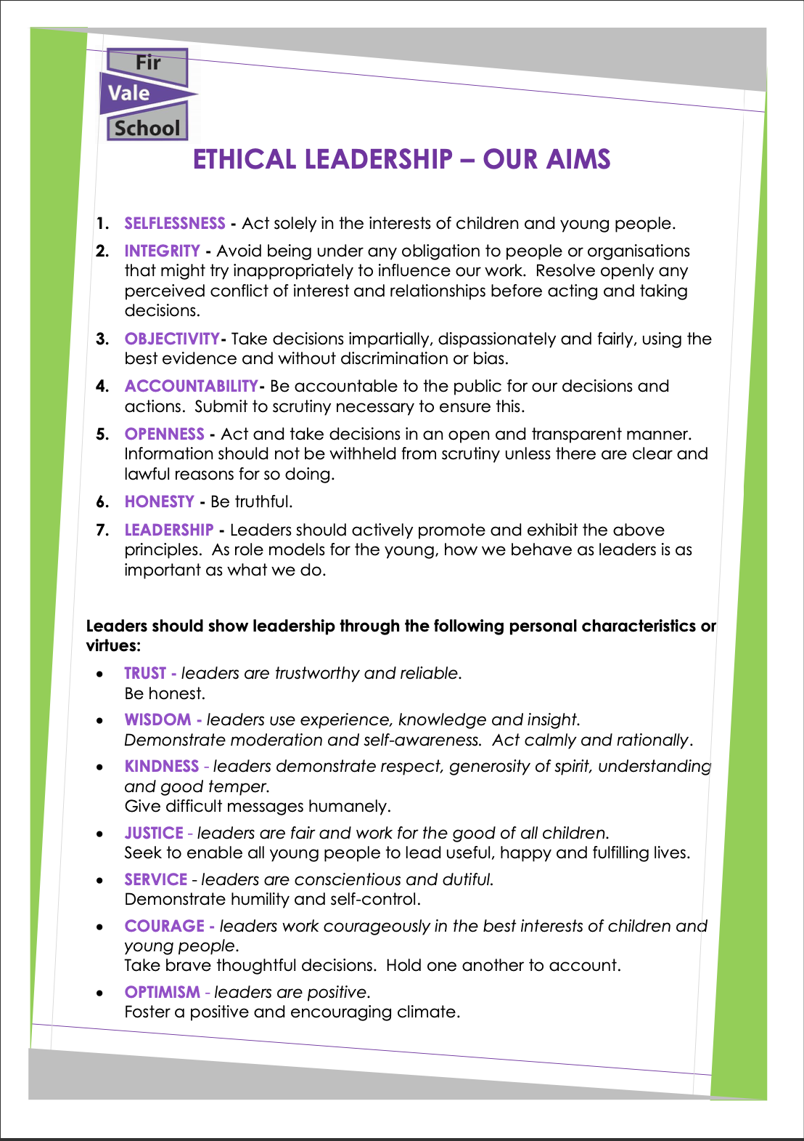
All the above duties and responsibilities to be carried out in accordance with Fir Vale School’s Policies, Standing Orders and current legislation with an emphasis on Customer Care, Equal Opportunities, Data Protection and Health and Safety

Person Specification

CRITERIA | ESSENTIAL | DESIRABLE
Qualifications | Educated to a high standard with equivalent of GCSE Grade C in English and Maths. | First aid at work qualification or willingness to undergo first aid training.
Experience | Experience of working effectively to support pupils.  Experience of working with pupils and families to raise standards of personal development, behaviour, welfare. | Experience of raising standards of attendance and punctuality  Demonstrable impact working with outside agencies.  Experience dealing with aspects of emotional intelligence including: emotional awareness, self-esteem, anger management, social and friendship skills, social communication difficulties, loss, bereavement and family break up or a willingness to undertake training to develop these further.
Knowledge & Skills | Ability to communicate effectively and build professional relationships with pupils, parents, staff and other stakeholders.  Effective use of ICT and technology.  Ability to work constructively as part of the pastoral team.  Knowledge of safeguarding issues, procedures and protocols. | Training in the relevant strategies for engaging students and working with families.
Personal Attributes | Empathy.  Flexibility to cope with diverse needs of the post.  Resilience to work under pressure.  Positive, personable and optimistic.  High level of commitment and attendance in current role. | Curious and enquiring and keen to learn from education research.

